Marketing Matters for Indie Authors
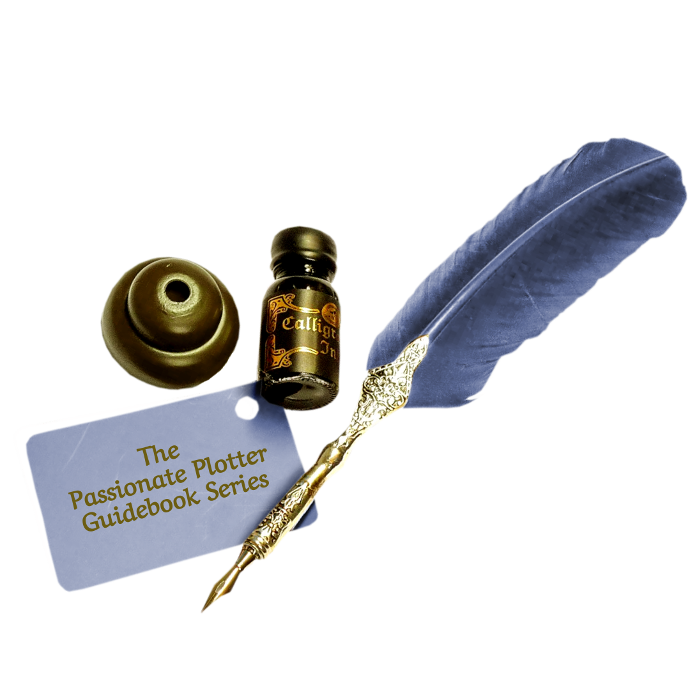
Reflection Prompts and Supplemental Worksheets

by Diana Kathryn Plopa

All rights reserved. No part of this publication may be reproduced, distributed, or transmitted in any form or by any means, including photocopying, recording, or other electronic or mechanical methods, either now known or unknown, without the written permission of the publisher, except in the case of brief quotations embodied in critical reviews and certain other noncommercial uses as permitted by copyright law. For permission requests, write to the publisher, address “Attention: Permissions Coordinator”, at the address below.
Creative Light Writers Guild
an imprint of Pages Promotions, LLC
Email: Info@PagesPromotions.com
Birmingham, MI 48009
www.PagesPromotions.com

© 2022 Diana Kathryn Plopa
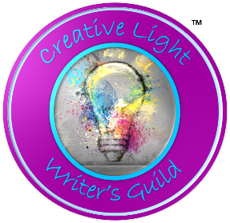
The Passionate Plotter Guidebook Series
Reflection Prompts and Supplemental Worksheets
Thank you for your purchase of The Passionate Plotter Guidebook: Marketing Matters for Indie Authors!
I appreciate your kindness more than you know. As my thank you, I have prepared these Reflection Prompts and Supplemental Worksheets for your continuous use. Because you purchased the book, these pages will be available to you each time you visit my website.
Inside, you’ll discover fillable, MS Word documents that can be worked directly on the screen, or printed, stapled, punched, or bound for hardcopy access as you are working on the marketing strategy for your book.
As discussed in the Guidebook, this is not an “all inclusive” or “exhaustive” resource, but there are many ideas here that you may find helpful as you begin to build a marketing strategy for your Indie Authored book.
Something to keep in mind is that each book you write, whether fiction, non-fiction, a children’s picture book, memoir, poetry… whether stand-alone or part of a series… each book you write needs its own marketing plan. Books are not widgets. They will never appeal to readers in the same way, even though they originated in your imagination. So, consider the source (you), the focus of your story, and your ideal reader before embarking on the marketing journey.
If you remember to treat each book… and each reader… as an individual, chances are you’ll sell more books and develop a devoted following of fans. Treat marketing with a “set it and forget it” or “build it and they will come” attitude, and you may be disappointed at the lack of recognition you and your book receive.
Yes, it is work. Yes, it can be tedious. But, if you put forth the dedication, you will rewarded in kind. So, use these pages to develop a strong plan, and return to these pages each time you embark on a new writing adventure. You’ll be glad you did.
Brand or Reputation
Building relationships with readers is paramount to building a solid, long-lasting career. But remember, that first introduction, more times than not, will be based on a tangible or visual exposure, rather than your witty repartee.
Use this space to brainstorm first on the visuals that you can use to invite your readers to discover your work, and then expand each idea to include how you might be able to build that initial connection into a lasting relationship with your reader.

Promotion
When considering your marketing plan, think of the “Drone’s Eye View” first, before you get knee-deep into the swamp of promotion. Use this space to brainstorm about the larger picture. How involved do you want to be in your book(s) marketing program? Is it important for you to make a transition from your “day job” to that of a full-time author? Can you afford the time, energy, and money it will take to do that? Or, are you simply interested in writing as a hobby or a side-hussle? Answering these questions will give you an idea of the budget for both time and cash.
Take the time to write out a list of both opportunities, and the pros and cons. After you’ve brainstormed through the options and the expectations, you’ll have a much better understanding of your tolerance for marketing and promotion. Use these lists as your guide to selecting the many different promotional tools available to you. This list will undoubtedly change over time, as your affection or exhaustion for the book world alters. I suggest you revisit your lists about every year or so, just to take your own inventory and adjust the sails of your writing career, when necessary.
Oh, one more thing… be sure to share these lists with the important people in your life… significant other, children, confidants, perhaps even business partners. Sometimes, just like editors, those who don’t live in our skin can help us to set priorities and direction for our marketing plan.

Writing As A Hobby |  | Writing As A Career
Pro | Con | Pro | Con

THE PSEUDONYM DISCUSSION
When choosing an author name, it’s important to remember that this is how people… readers, fans, bookshop owners, media representatives… will know you. Be sure to choose a name that is comfortable for you, one you don’t mind signing repeatedly, and one you can easily respond to in a crowded room. When I was young, I quickly discovered that in order to get my mother’s attention in a room full of adults, calling her “Mom” almost never worked, I had to call her by name, “Nancy”. Otherwise, seventy women would either all turn their heads simultaneously, or ignore me simultaneously, thinking it was some other mother’s child calling. Humans are not as astute at listening for familiar voices as animals are… so be sure that the name someone calls you is one you have laser attention on.
Use this space to brainstorm possible author names, if you’re planning to use a pen name. Can you use a portion of your given name? Do you have a nickname that gives you warm fuzzies? If you’re married, will you use your family surname, or your spouse’s? Is there a name from literature that you’ve always admired, and dreamed about using when you became a writer?
Just like with your first crush, practice signing your name as you imagine it will be printed on the title page of your book, use this space to imagine that day, and become “married” to your pen name. After all, it’s going to be with you for your lifetime.

The Street Team
Loyalty should be rewarded. Use this space to brainstorm some ideas about how you might say “Thank You” to your Street Team members. Perks might be anything from free ARC copies to a gift card for dinner at a swanky restaurant, or a host of other fun ideas. What is the best way you can show gratitude to those who support your writing career?

The Dreaded Synopsis
Here is a suggested blueprint of The Dreaded Synopsis. This can be a helpful guide when you’re crafting your book’s, back matter, and non-fiction book proposal. Tweak it over the course of several days or weeks, to make sure that you have the right words, emotion, and most importantly, distance. Just when you think you’ve got it right, tuck it in a drawer for a few days and look at it again with fresh eyes. Sometimes, forgetting that you’re the author can be the best way to craft a synopsis that will hook readers.
Try writing several versions and compare them after you’ve taken a break from the process. Which one tugs on your imagination or your need for information? Which satiates your curiosity or desire for escapism the most?
- Headline: One sentence, about 200 characters. Start with a bold first line of about 25 words. Include major topics, themes, and/or genres that potential readers might be searching for. This first line is critical for SEO, discovery, and is the first hook you’ll use to entice readers to read more, so make it count.

- Exposition: Give readers the details they need to make a buying decision. Who or what is the book about? Where and when is the story set? What happens? Tease the basic plot without giving away critical details, or the ending. If this is a non-fiction or how-to book, consider using bold or italic fonts, and bullet points to draw attention to important features. One concise paragraph is all you need.
- Close: Emphasize the value of the book, its intended audience, and your brand promise. Who should buy this book? What will they get out of it? Why should they buy it now? What problem will be solved, either fictionally or in real life? What question will be answered?

The Festival Pitch
Think about all the pieces that go into a personal appearance. From the floor to the ceiling, what will you need to make the best impression possible? What will you need to create memory triggers, and retain your business perspective? Use this space to brainstorm a checklist of elements to include in fairs, festivals, and bookshop signings. I’ve given you a few ideas to get you started. Add others as they come to mind and refer back to this list as you prepare for each event. Fine-tune the list as you learn what works best for you and your books, taking into consideration the venues where you feel most comfortable.
Indoor Events:
☐ | Book inventory
☐ | Tablecloth
☐ | Book displays or shelves
☐ | Signs and banners
☐ | Cash box
☐ | Credit card processor
☐ | Inexpensive memory trigger giveaway
☐ | Newsletter sign-up sheet
☐ | Order forms for when you run out of books
☐ | Gift Bundle Kits (i.e. book, puzzle, plush)
☐
☐
☐
☐
☐
☐
☐
☐
☐
☐
☐
☐
Outdoor Events:
☐ | Everything for the Indoor Event
☐ | Tent or canopy
☐ | Tent weights or tie-downs
☐ | Table
☐ | Chair or stool
☐ | Water dish for visitors with dogs
☐ | Weights to anchor signs and books
☐ | Trash can
☐ | Bottles of water (this could be a giveaway if you put your logo on them)
☐
☐
☐
☐
☐
☐
☐
☐
☐
☐
☐
☐
☐
☐
☐
☐
☐
☐
☐
☐
☐
☐
Considering The Competition
Try this exercise as a way to discover your competition. Brainstorm a list of elements that live well inside your book. Your list might include character traits, plot tropes, settings, weapons, methods to solving crime, camouflage for keeping secrets, the intensity of love or hate, the inclusion of animals, children, or aliens… the list might be long or short but give yourself some time to come up with as many different elements as possible.
Next, from that list of elements, create a second list of the ones you feel are most critical to the story you are telling, the skill you are teaching, or the emotion you want your reader to embrace.
Then, search through your local library’s book catalogue, or Amazon’s book list for these keywords. Make “hash marks” every time you find a book that includes these elements. After a couple of hours, you’ll start to see a pattern of the most prevalent elements.
Make another list of these top five keywords, or if you really want to get specific, the top three keywords. Now search for books that include those specific elements. Make a list of those books. These are your competitors. This shortlist is how you will compare your book to readers when you craft your marketing messages.
Once you’ve discovered your book’s competition, make friends with those authors on social media and, if you have the opportunity, at in-person events. Become reciprocal in your support of their writing careers through book reviews, sharing of social media messages, or becoming table buddies at festivals. Because we are not competing against each other, but instead comparing our work for readers so they can discover us and recommend us to their friends who like the same books… creating a network within the craft is exactly the right choice.
This is how MasterMind Networking Groups work, and this is why organizations like The Horror Writing Association, Science Fiction and Fantasy Writers Association of America, and the Society of Children’s Book Writers and Illustrators enjoy so much success. It’s because they see each other not as rivals but as allies, each helping more readers to discover their work.

Focus Elements |  | Keyword Occurrence
Primary | Secondary | Library | Amazon

The Top Five Keywords:

The Top Three Keywords:

Book Titles That Include the Top Keywords:

Additional Notes:

The Enthusiastic Four Week Marketing Timeline
 | Date | Notes
Week One:
Final Layout Complete | Click or tap to enter a date.
Excerpt Share | Click or tap to enter a date.
Week Two:
Public Cover Reveal | Click or tap to enter a date.
Podcast or Blog | Click or tap to enter a date.
Order Author Copies for Release Event! | Click or tap to enter a date.
Podcast or Blog | Click or tap to enter a date.
Book Trailer, Blog, or Podcast | Click or tap to enter a date.
Week Three:
E-Book Release | Click or tap to enter a date.
Book Trailer | Click or tap to enter a date.
Excerpt Share | Click or tap to enter a date.
Book Trailer | Click or tap to enter a date.
Public Release Announcement | Click or tap to enter a date.
Book Trailer, Blog, or Podcast | Click or tap to enter a date.
Review Shares | Click or tap to enter a date.
Week Four:
Launch Day | Click or tap to enter a date.
Public Release Event Reading & Signing | Click or tap to enter a date.

The Patient Six Week Marketing Timeline
 | Date | Notes
Week One:
Final Layout Complete | Click or tap to enter a date.
Week Two:
Cover Reveal Tease | Click or tap to enter a date.
Excerpt Share | Click or tap to enter a date.
Week Three:
“Secret” E-Book Release | Click or tap to enter a date.
Podcast of Blog | Click or tap to enter a date.
Week Four:
Public Cover Reveal | Click or tap to enter a date.
Order Author Copies for Release Event! | Click or tap to enter a date.
Book Trailer, Blog, or Podcast | Click or tap to enter a date.
Week Five:
Private Reading Event | Click or tap to enter a date.
Book Trailer | Click or tap to enter a date.
Except Share | Click or tap to enter a date.
Book Trailer | Click or tap to enter a date.
Week Six:
Public Release Announcement | Click or tap to enter a date.
Book Trailer, Blog, or Podcast | Click or tap to enter a date.
Review Shares | Click or tap to enter a date.
Launch Day! | Click or tap to enter a date.
Public Release Event Reading & Signing | Click or tap to enter a date.

Launch Event Standouts
How can you make your Launch Event really stand out? The goal is not only to share your book with readers, but to also make it such a memorable event that those who attend will talk about it afterward, which will create curiosity about the book, which may translate into more sales. Use this space to brainstorm about things you can incorporate into your event that will make an impact on the day, and long afterward.
Don’t be afraid to use your imagination and test out ideas that initially seem a little far-tetched. Remember, this is supposed to be a fun event that people will remember. You want them to not only buy your book that day, but also talk about your book and the venue long after you’ve said goodnight.
In the next chapter, we’ll talk more about the actual reading aloud process, with all the details of presentation, dress, etc.
Here are a few ideas to get you started:
☐ | Costume contest
☐ | Petting zoo
☐ | Animal adoption event
☐ | Trivia “quiz” about the excerpt you’ve read.
☐ | Roving magician or balloon animal artist
☐ | Interactive art demonstration
☐ | Craft make and take
☐ | Share the event with an expert speaker related to your book
☐ | Donation for a charity that’s related to your story
☐ | Share a Launch Event with another author
☐ | Wine tasting
☐ | Live performance of the excerpt from your book (this is a lot of fun if you have friends who are actors)
☐
☐
☐
☐
☐

The Press Release
Press Releases, like story writing, takes practice. You need to spend some serious time in brainstorming and getting it just right.
On the following pages, you’ll be prompted to write the segments of your Press Release. Most authors don’t think like marketers, so sometimes this process can be a bit overwhelming. Brainstorming on the individual pieces can be helpful. Just like writing the Dreaded Synopsis, this exercise is one you should repeat until you get it exactly where you want it.
Remember, each book, even those in a series, need their own Press Release. Generic writing for reporters will not get your work noticed, it’ll just annoy them. So while you may repeat a few segments, like the contact information, author bio, and if you’re fortunate enough to have a sponsor that loves you and your work, an event location… make sure the rest of it is very specific to each title.
When you’ve finished, get beta readers who DON’T know anything about your book to read your press release. If they are genuinely interested to learn more, that’s when you know the release is ready to send out into the world.
PRESS RELEASE PRACTICE
Headline:
SubHeading (optional):

Date & Location:
Introduction:

Author Quotation:

Mini Author Bio:

Book Information:

Contact Details:

Call To Action:
Hashtags (optional)

Press Release Submission Tracking is an important part of the marketing process. You need to know who you sent what, and if you’ve followed up or not… and most importantly, whether or not that particular media outlet supported your event or book release.
Keep track of it all on the following pages, and then analyze what worked so you can duplicate those efforts the next time around.
Save yourself a lot of rejection heartache… only send press releases to media outlets who are relevant to your book or event. If your book is about fishing, don’t send it to “Densit’s Quarterly”; but do send it to “Fish & Wildlife”.
PRESS RELEASE TRACKING WORKSHEET:
Date Sent | Sent To | Email | Snail Mail | Phone
Click or tap to enter a date. |  | ☐ | ☐ | ☐
Results:
Click or tap to enter a date. |  | ☐ | ☐ | ☐
Results:
Click or tap to enter a date. |  | ☐ | ☐ | ☐
Results:
Click or tap to enter a date. |  | ☐ | ☐ | ☐
Results:
Click or tap to enter a date. |  | ☐ | ☐ | ☐
Results:
Click or tap to enter a date. |  | ☐ | ☐ | ☐
Results:
Date Sent | Sent To | Email | Snail Mail | Phone
Click or tap to enter a date. |  | ☐ | ☐ | ☐
Results:
Click or tap to enter a date. |  | ☐ | ☐ | ☐
Results:
Click or tap to enter a date. |  | ☐ | ☐ | ☐
Results:
Click or tap to enter a date. |  | ☐ | ☐ | ☐
Results:
Click or tap to enter a date. |  | ☐ | ☐ | ☐
Results:
Click or tap to enter a date. |  | ☐ | ☐ | ☐
Results:
Click or tap to enter a date. |  | ☐ | ☐ | ☐
Results:
Click or tap to enter a date. |  | ☐ | ☐ | ☐
Results:
Click or tap to enter a date. |  | ☐ | ☐ | ☐
Results:
Read Aloud
Take some time to brainstorm about places where you would have fun reading your book aloud. Think outside of the usual places like libraries and bookshops. Is there a place or meaningful totem that directly connects to your story or characters? Try finding a place that would fit. For example, if your cozy mystery features a bakery, check with the local cookie shop or coffee house and see if they would host your reading. If a dog is your hero’s sidekick, ask a local animal shelter if you can do a reading during their next adoption event. Remember, readers, come from every walk of life, and they don’t just hang out in libraries and bookshops. So go read to them where they are!
Use the space on the next page to fiddle around with different ideas for a reading event. Focus on places where it won’t cost you anything to read, but both you and the host will benefit from the foot traffic.
Book Totem or Location | Possible Event Space
Giveaways, Website, Social Media
Take a few minutes to brainstorm ideas for takeaways for your festival table. Think back on all the times that you attended an event, whether as a child or as an adult, what stuck with you as a memorable “take-away”? Sift through your “junk” drawer in the kitchen or laundry room… how many little things have you tucked in there that you received free from an event, fair, trade show or baby shower? What have you kept, and why? Consider those items as you think about what might be fun additions to your reader’s “junk” drawer.
One more thing… how many toys does your child still have that are left over from “happy meals”? Those things that they held on to, they kept for a reason. Ask them why, and then use those ideas when scouring the Internet for promotional items for your table.
Don’t forget to try to work in anything that might be a connection to your book in any way. Even if the link is a small one, it’s still a link you can use to draw attention to your book.

Book Link | Promotional Item
Websites
Do a little bit of research into websites. You can hire a website done for you, or you can build it yourself, it all depends on your level of computer comfort. Think about what you want your website to do for you, and how involved you want to be with it on a daily or weekly basis. Take a few days to really think about this. Sure, you can always change your mind about the build, but establishing your comfort zones and budget now will save you a lot of headache later.
Use this space to answer these questions:
- What is the main purpose of your website?
  - A simple showcase of your work
  - Interactivity between you and readers
  - Buying and selling
- What is your comfort level in designing a website? Do you want to code, or are you more comfortable with plug-and-play, drop-and-drag? Would you rather just hand it off to someone else, entirely?
- Do you have an idea of what you want it to look like, a theme, color scheme, does it show a video or play music when people visit?
- What features do you want included?
  - Online shopping
  - Blog
  - Interactive chat
  - Sync with your calendar
  - Email capture
  - Pop-Up ads
  - Something else??
- What is your budget? Do some Internet research or talk with friends. What’s it going to cost?
Brainstorm Your Notes In The Space Below…

Social Media
How comfortable are you on Social Media? Some people never use it at all, and others dive into the deep end, getting their flippers wet with every opportunity to share, tweet, and promote. Do what makes you happiest. But remember that what you put out there, stays out there… Forever.
Use this space to take notes as you investigate the different social medial platforms. Talk with your friends and other authors to learn all you can about time requirements and how to best use this tool. Pay attention to what others are doing, and again, observe to emulate, not to steal.

Peer Groups & Readers
Spend some time talking with your peer group and your readers. Chat with your best friend, and that nice lady who checks out your groceries or cuts your hair. They all have valuable insight into what types of social media platforms will work, or at the very least, what they prefer. Then, go talk with your family and your co-workers, These are probably people you interact with regularly, and their social media habits can offer additional insight into the comfort areas and the requirements of time and attention. Spend a few weeks and have lots of conversations. The conversations you have will be tremendously valuable when you begin your trip down the Social Meidal Rabbit Hole… they’re all there, doing it right along with you… learn from them.

Visual Presentation
Think about the many different ways your book can be presented visually. Many of us have already imagined our story as a TV program, film, or stage play. Consider those influences and flights of fantasy when creating video to support your writing career. Is there a particular scene in your story that you just know would look great on the screen? Why not ask your friends to help you bring it to life. Do you have a special skill or process in your how-to book that is best understood when you demonstrate it? Pull together all the materials and set your camera on a shelf with a wide shot, and show off your expertise. Do you have musician friends who would like more exposure for their careers… ask them to put music to your poem, and then make your own music video… everyone benefits.
Use the space on the next pages to brainstorm a storyboard of how your video might be produced. In each square, draw little stick figures with dialogue bubbles, or captions. Or, write a script taken directly from the pages of your book and enlist your friends to lend their voices.

Storyboard:

Storyboard:

Script:

Script:

Podcasting
Investigate the podcast providers in the list above, and any others you may discover.
Choose three that you think will work best with your goals of your podcast and lifestyle. Which three do you like best, and why? What are the ”pros” and “cons” of each of your top three selections. Circle the one that makes the most sense for your criteria and set up an account on that platform.

Podcast Technology
What technology will you need to produce your podcast? How involved do you want to be with buying new tech and learning how to use it?
Do a little bit of research on microphones, pop shields, headphones, and earbuds. Make a list of all the technology on your WISH LIST, if cost and space were no option, what would you buy? Be sure to include the costs for that equipment.
Now, put a check mark next to the equipment that you absolutely NEED to produce a podcast within the next month. That’s where you’ll begin. Add to your equipment collection as time and money permit, keeping in mind that you don’t want to buy a lot of equipment you’ll never use again, if you discover you’re discontinuing your program.
Have | Need | Want | Equipment
☐ | ☐ | ☐
☐ | ☐ | ☐
☐ | ☐ | ☐
☐ | ☐ | ☐
☐ | ☐ | ☐
☐ | ☐ | ☐
☐ | ☐ | ☐
☐ | ☐ | ☐
☐ | ☐ | ☐
☐ | ☐ | ☐
☐ | ☐ | ☐
☐ | ☐ | ☐
☐ | ☐ | ☐
☐ | ☐ | ☐
☐ | ☐ | ☐
☐ | ☐ | ☐
☐ | ☐ | ☐
☐ | ☐ | ☐
☐ | ☐ | ☐
☐ | ☐ | ☐

Podcasting Finances
Think about the costs involved with your podcast. How will you manage this new marketing endeavor, while writing or working at your “day job”? Make all the “what if” notes and write out each scenario as a test.
- Do the numbers add up?
- What is the total cost to you?
- How much do you need to bring in with donations or subscriptions to offset your costs?
- What do you feel you can comfortably charge for a listener subscription?
- Will you collect donations and subscriptions through your website, through your podcast platform, or another site like Patreon?
It’s important to understand these small details of cost so you can balance your writing career and the marketing of that career intelligently, without regret.
Platform Name | Platform Cost | Equipment Cost | Subscription Rate | Return On Investment (Income)

Podcast Theme
What is your show going to be about? How will it impact the listener, the community, your career? What is the WHY behind your motivation for stepping out to produce a podcast? Are your dreams in alignment with support of your career as well as in alignment with what is interesting to listeners?
Use this space to answer the questions from this section, and to brainstorm what you think your show might look like, once it goes live.
You may also find it helpful write some opening dialogue and closing dialogue to “bookend” your show. How will you introduce the theme each episode and how will you wrap it all together at the end?

Podcast Title
Use this space to brainstorm titles for your program. Will you use your name in the title? How can you use your theme to identify your show? Can you incorporate alliteration, metaphor, or color into a title, to make it more memorable?
Free-write for ten minutes, concentrating on title ideas, without censoring yourself. Then look over the list and see which ones you like best. Can you combine some phrases to make your podcast’s title stand out?
Choose your top-three favorite titles and let them sit for a few days. Then, come back to this list and go over it again. Are your favorites still speaking strongly to you? If not, try the exercise again until you find just the right title for your show. Remember, this is as important as your book’s cover. It’s the first impression listeners will have for your program. Hook them, and then keep them coming back
Podcast Show Notes
Who will you talk to on your show? Are you planning to simply host information or ideas without a guest, or will you invite another someone to join you? What will you say?
Use this space to brainstorm some questions you think listeners might be interesting in hearing. Will you ask your guest to read an excerpt from their book, or offer some wisdom? How might that conversation go?
I’m making the assumption that if you’re reading this series, you’re also a writer. So write. Brainstorm a few conversations between you and your guests. Write out some interview questions. Which ones are “evergreen” and which would be specific to each guest?
Test-driving situations like these will help with making you feel more comfortable about your conversations with your guests the day you record, and it’ll take the anxiety out of your show, making it more enjoyable for your audience.

Podcast Show Schedule
How often would you like to produce a show? What’s your “dream” schedule? Now, what’s realistic? What day of the week works best for you to record? If you’re doing a live show, what time and day is best for you? What works best for the guests you’ll be asking to join you. Do you want your guests to suggest dates and times, or will you give them two or three options, and then assign a date and time based on their general preference?
Brainstorm two calendars, one for recording and one for a live show. Which is more doable? In each square, note one of the following, to track your frequency, redundancy, and avoid overlaps:
L = Broadcast Live
R = Record an episode for later Broadcast
B = Broadcast the next episode
O= Off, no broadcasts or recordings
Sunday |  | Monday |  | Tuesday |  | Wednesday |  | Thursday |  | Friday |  | Saturday
Morning |  | Morning |  | Morning |  | Morning |  | Morning |  | Morning |  | Morning
Afternoon |  | Afternoon |  | Afternoon |  | Afternoon |  | Afternoon |  | Afternoon |  | Afternoon
Evening |  | Evening |  | Evening |  | Evening |  | Evening |  | Evening |  | Evening
Notes:

Podcast Advertising
Advertising opportunities can show up in the most unusual places. Try thinking outside the typical box of advertising “go-to’s”.
Do you know someone who has a restaurant, a dry-cleaning business, or a flower shop? Would any of these potential book lovers allow you to put a small sign near their register with a QR Code to your podcast? You could thank them with a “sponsored by” message on your program.
Run through the contacts in your email, phone, and address book. Think about organizations you belong to, and those individuals who might be willing to help support your new endeavor.
Use this space to list those people, their business, and how your show could add value to their clients, or their business.
Then, next to each, make a note about how you can support them, in return for their kindness.
Then, give them a call. Remember, they can’t say “yes” until you ask the question.

Contact | How Can They Help You? | The Value You Add for Them | How They Can Support You | How You Will Say Thank You

Podcast Post Links
Think about where you see the majority of links that you click on… Do you find them in social media, in Newsletters, at the end of op-ed articles on Medium, or in the comments listed under YouTube videos? Think about where YOU find links to click on, and then mimic those advertisers. Chances are, if they got you to click on a link, that’s a place where a lot more people also found their links, too.
Use this space as a log for a few days. Keep it near your computer, and each time you find yourself clicking on a link, record what platform got your attention.
At the end of five or six days, tally your results. The top three platforms that got you to take action is where you should put your click-through links, too.
Date | Platform | Link
Click or tap to enter a date.
Click or tap to enter a date.
Click or tap to enter a date.
Click or tap to enter a date.
Click or tap to enter a date.
Click or tap to enter a date.
Click or tap to enter a date.
Click or tap to enter a date.
Click or tap to enter a date.
Click or tap to enter a date.
Click or tap to enter a date.
Click or tap to enter a date.
Click or tap to enter a date.
Click or tap to enter a date.
Click or tap to enter a date.
Click or tap to enter a date.
Click or tap to enter a date.
Click or tap to enter a date.
Click or tap to enter a date.
Click or tap to enter a date.
Click or tap to enter a date.

Podcast Make It Memorable
How can you add value and entice more listeners to your program? Consider working with your guests to brainstorm about ways the two of you can work together to bring attention to both of you and your books. Is there a holiday that might be coming up around the time a particular show airs, that ties into the topic for your podcast? For instance, if you have an author on as a guest who has written a book about Santa Clause, what sort of “after show perk” can you offer to those listeners that would celebrate the holiday and the book, simultaneously?
Remember, your show’s content should be “evergreen” but the after-show perk doesn’t necessarily have to be. Any marketing tool you can use to draw attention and create memory triggers that benefit both you and your guest are worth exploring.
Use this space to free-write some ideas. Start with the outlandish and narrow your focus to the more realistic. Somewhere in the middle, you’ll find an ideal perk that you may be able to use with every guest, with minor tweaks. This repetitive offer may be a great way to build your fan base.
The Media Kit
There is a lot involved with the building of a media kit. I’ve given you a fairly extensive list in this chapter, but I’m sure I’ve missed something. Use this space to make a list of everything you’ll need. Check off whether you have it or need it, and if you need it, when do you expect it’ll be ready? Building a media kit is note something you do overnight. It takes a lot of thought and collection of all the materials. Consult with your author friends and find out what they’ve included in their media kits, find out what’s worked for them, and what’s been a waste of time.
If you’re really brave, reach out to a local radio or television station and ask them what they require in a media kit when they consider interview guests. Every station will have a different set of criteria, but through that list, you’ll come up with a good base line. Then, you can tweak it to fit the specific stations you’d like to court.

Have/Need | Media Kit Elements
Amazon A+ Content
Consider the message you’d like your reader to take away from your book. If it is non-fiction, what the most valuable reason that a reader should buy it? If your book is fiction, what is the most compelling character, storyline, or quest that you want your reader to become embroiled in as they read? These are the points which will work as the foundation for you’re A+ Content.
Use this space to brainstorm the WHY that should motivate readers to buy your book.
Then, spend some time rephrasing that message as a referral from that reader to another reader.
Finally, take a few minutes and create a visual something… meme, ad, whatever you like to call it… that will draw readers to feel that their lives will be enriched if they click “add to cart”.
What Is The WHY?

How Can Your WHY become a Referral?

What Design Can You Create From This Message?
Storyboard It!

Perspectives On Rejection
Your rejections should be celebrated as a rite of passage as you travel along your author journey. Dwelling on them as black marks won’t make them go away, they’ll just get in your way, making writing the next book even harder.
Use this space to list a few ways that you can celebrate your rejections as moments of growth and change and reward yourself for the courage and tenacity this industry expects.
When I receive a rejection, this is how I will celebrate and reward myself for not giving up!

Extra Marketing Ideas
I’ve only offered a few alternative marketing ideas here, I’m sure there are a lot more. Have a conversation with your friends and family. Brainstorm ideas about how you can share your gift of story with others. You may get paid, you may not. But truly, making literacy a part of your legacy is one of the best things you can do.
Use this space to make a list of “out of the box” marketing ideas. Ask your children. Kids are fantastic idea makers of brave, unusual opportunities. They have wild imaginations and no boundaries. Then, try out a few on the list, see what works, what you enjoyed, and repeat those.

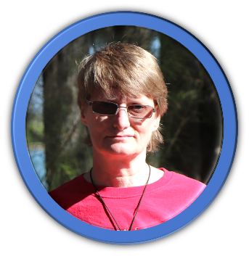
ABOUT THE AUTHOR
Diana Kathryn Plopa is founder, publisher, editor, and mentor at Pages Promotions, LLC. She believes in fostering a love for the written word in all its forms. Her love of literacy knows (almost) no bounds.
Diana Kathryn has worked as associate publisher, editor, writing coach, for two small press publishers, as well as a bookshop manager. and bookshop manager. She has assisted over three hundred Indie Authors creation and promotion of their books in Michigan and beyond. She holds a degree in English, with a concentration in creative composition, as well as a certification in early childhood development.
Diana Kathryn spent time as a features writer for a Detroit newspaper, and as a content writer for a popular Detroit radio program, as well as various community television. She was also extensively involved in Detroit reparatory theatre, as a technical director and lighting designer, for fifteen years.
Drake, the Duck Muse helps her with the tough stuff, quacking inspiration in her ear whenever she might need it. Their imaginations are fueled by an abundance of hot cocoa as they write together.
Diana Kathryn and her husband, Dave, collaborate on a children’s book series, that helps little people understand the challenges of growing up. She writes the words and he brings them to life on the page with his spectacular artistry. Their two dogs, Charlie and Finnigan help to keep life exciting.
When not writing, Diana Kathryn enjoys reading; hiking; kayaking; escaping to their cabin in the woods to write; spending time with her husband and son, Zachary; cheese in large quantities; chocolate; Carl Orff, and Mozart.
www.DKPWriter.com
www.PagesPromtoions.com

TITLES BY DIANA KATHRYN PLOPA
- A Duck Quacks
- A Tryst of Fate
- Ideate Avail
- Free Will
- Emmett Elephant’s Love; Illustrations by David D. Plopa
- Wolfe Cub
- The Passionate Plotter Guidebooks
- The Passionate Plotter Kids

Books In Process
- The Crimson Key (a swashbuckler fantasy novel)
- Hot Cocoa (a collection of anecdotal essays)
- Take The Reins (a young adult novel)
- Henry Hippo's New Home (a children's picture book; book two in the Smart Ears Safari Club series)
- Chloe Chimpanzee's Clutter (a children's picture book; book three in the Smart Ears Safari Club series)
- Tears Remember (a paranormal novel)
- The Scribe's Apprentice (a historical-fiction novel)
- Splinters (a western novel)
- Anonymous (a suspense novella)
- American Plague (a political thriller series)
- The Last Strand (a science fiction novel)
SOCIAL MEDIA CONNECTIONS
Follow Diana Kathryn Plopa On Facebook At
https://www.facebook.com/groups/dkpliterarystreetteam
Learn More About Pages Promotions, LLC At
www.PagesPromotions.com

Follow Pages Promotions On Facebook At
https://www.facebook.com/groups/indiereads

Follow Pages Promotions On Instagram At
PagesPromotions

#Indiereads
#Powerofthepen
#Drakesays
#Literarystreetteam
#Flashfictionchallenge

